Translation

Definition
# Source: AI Source: Provided by: [Data Path: Persons Table -> ID Column: 1, Name_En Column: Motasem Essam] -> From: [ChatGPT] on [7/25/2026]
Translation is a geometric transformation that moves every point of a figure the same distance in the same direction.
A translation changes the position of a figure without changing its:
- Shape
- Size
- Orientation
- Angles
- Side lengths
The original figure and the translated figure are therefore congruent.
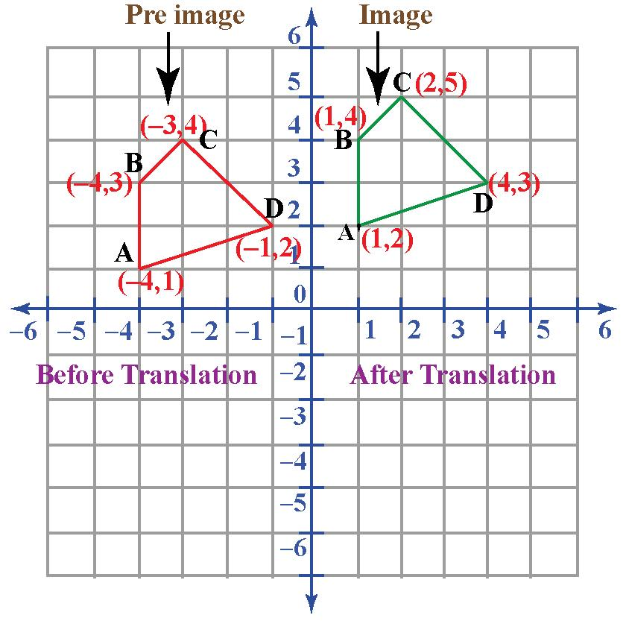
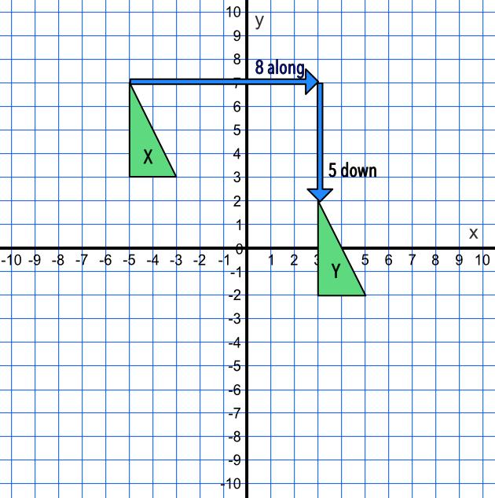
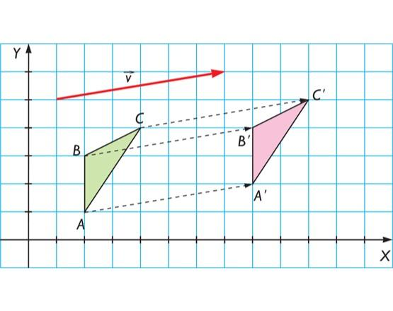
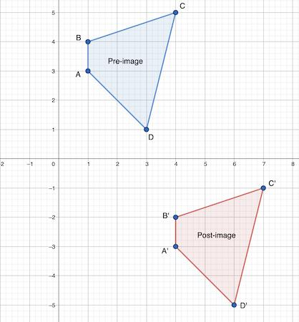
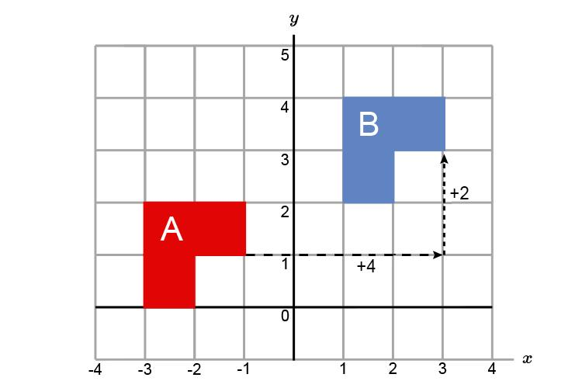
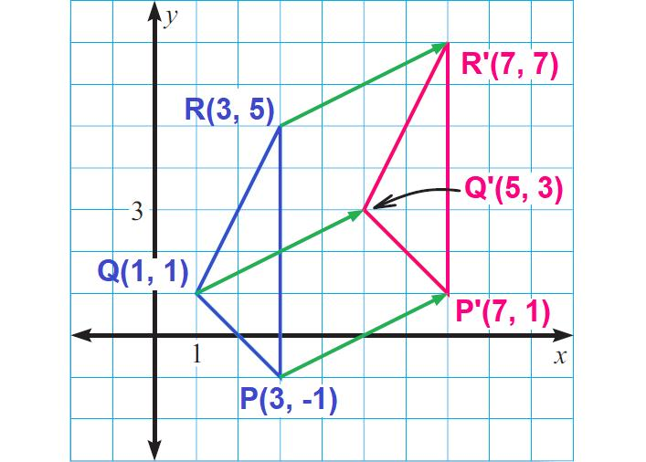
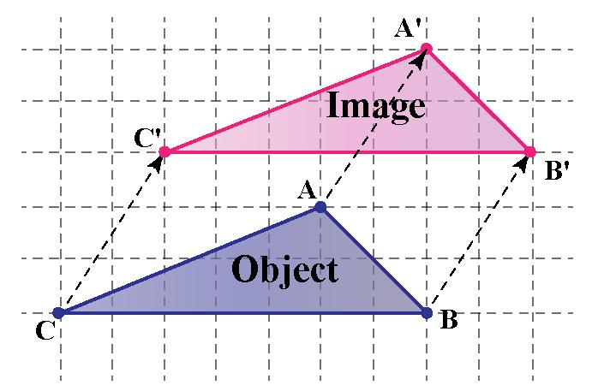

Purpose
# Source: AI Source: Provided by: [Data Path: Persons Table -> ID Column: 1, Name_En Column: Motasem Essam] -> From: [ChatGPT] on [7/25/2026]
Translation is used to:
- Move geometric figures without changing their shape.
- Change the position of objects.
- Study geometric transformations.
- Describe movement using vectors.
- Transform coordinates.
- Create repeated patterns.
- Model movement in computer graphics.
- Support CAD and engineering design.

Fundamental Idea
# Source: AI Source: Provided by: [Data Path: Persons Table -> ID Column: 1, Name_En Column: Motasem Essam] -> From: [ChatGPT] on [7/25/2026]
A translation moves every point by the same displacement.
For example, if every point moves:
- $4$ units to the right
- $2$ units upward
then the translation is:
$$\boxed{\left(x , y\right)→\left(x , +4y+2\right)}$$
The entire figure moves together.
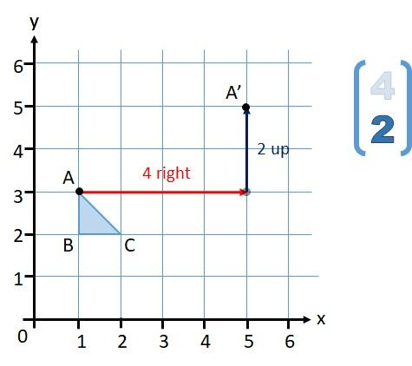
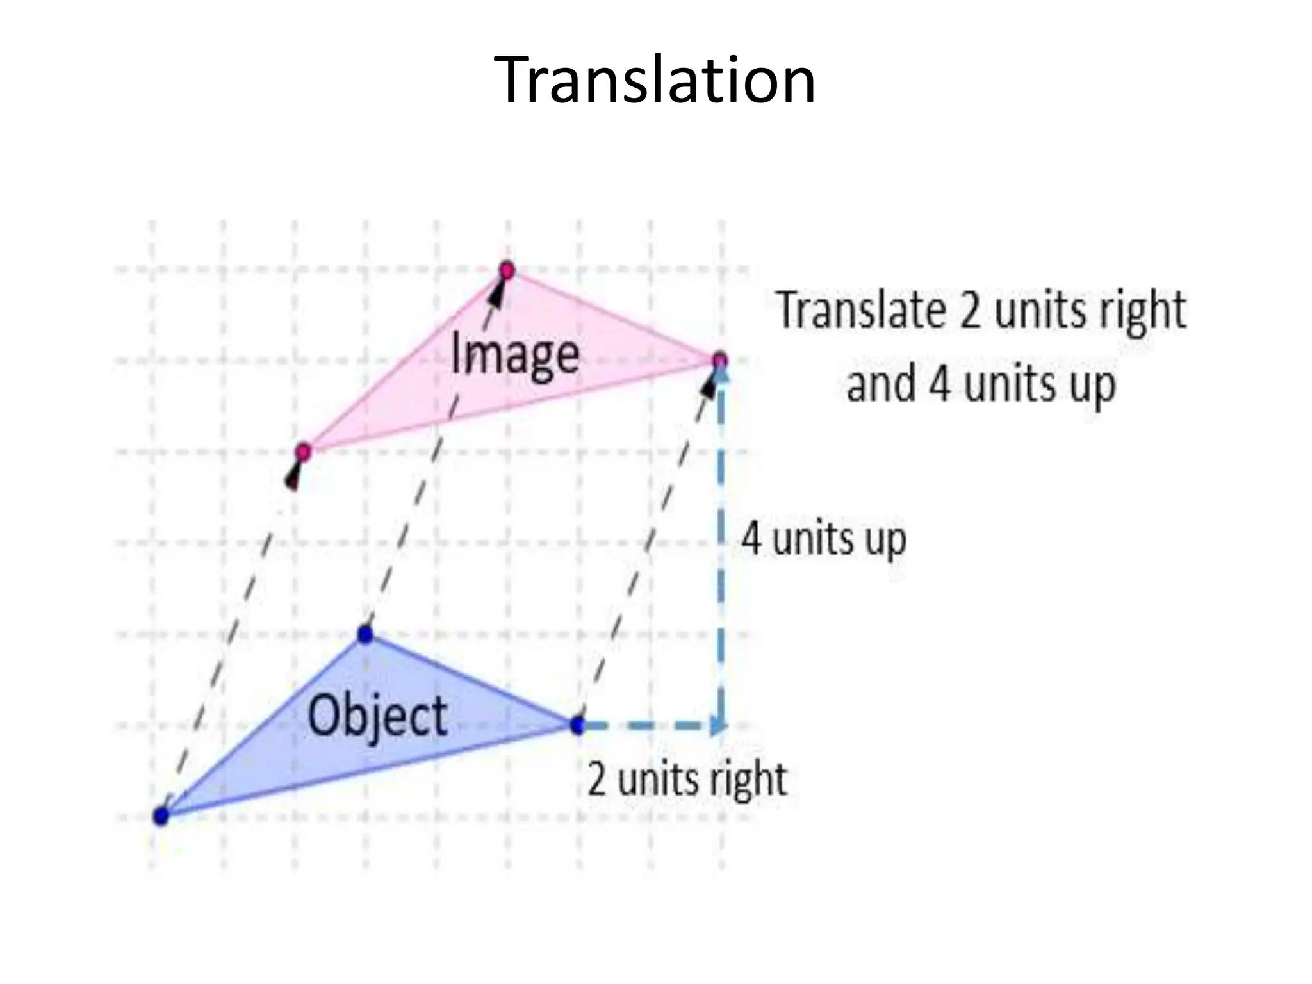
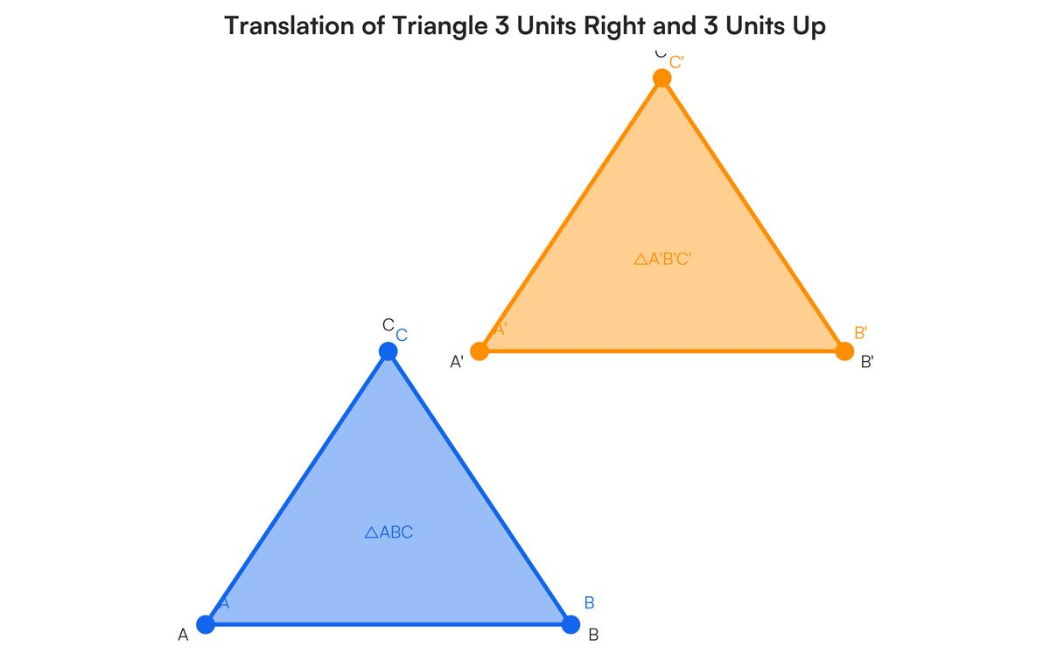
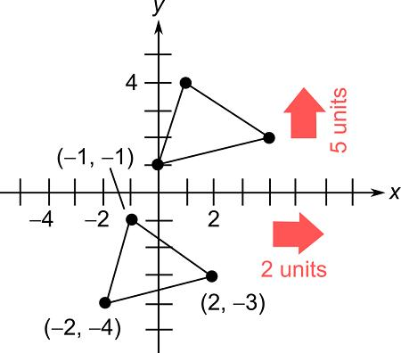
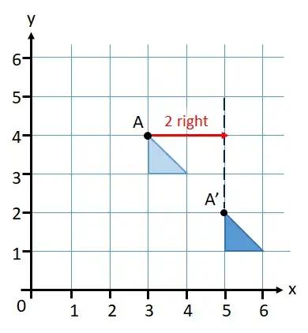

Translation Vector
# Source: AI Source: Provided by: [Data Path: Persons Table -> ID Column: 1, Name_En Column: Motasem Essam] -> From: [ChatGPT] on [7/25/2026]
A translation can be represented by a vector.
A translation vector is commonly written as:
$$\boxed{\left(\begin{matrix}a \\ b\end{matrix}\right)}$$
where:
- $a$ = horizontal displacement
- $b$ = vertical displacement
The transformation is:
$$\boxed{\left(x , y\right)→\left(x , +ay+b\right)}$$

Horizontal Translation
# Source: AI Source: Provided by: [Data Path: Persons Table -> ID Column: 1, Name_En Column: Motasem Essam] -> From: [ChatGPT] on [7/25/2026]
If:
$$b=0$$
the figure moves horizontally.
Right
$$\boxed{\left(x , y\right)→\left(x , +ay\right)}$$
where:
$$a>0$$
Left
$$\boxed{\left(x , y\right)→\left(x , -ay\right)}$$
where:
$$a>0$$
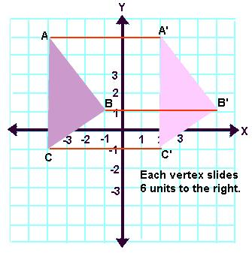
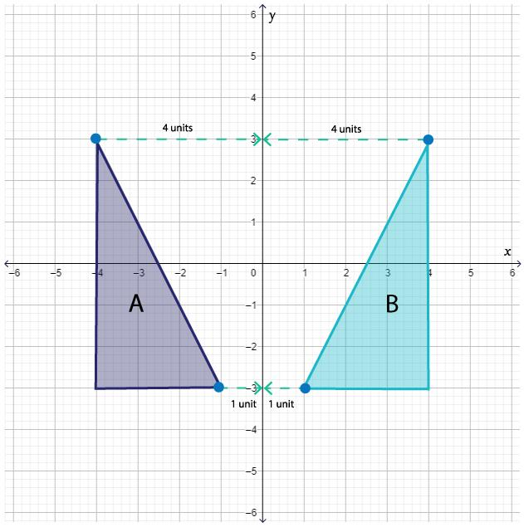
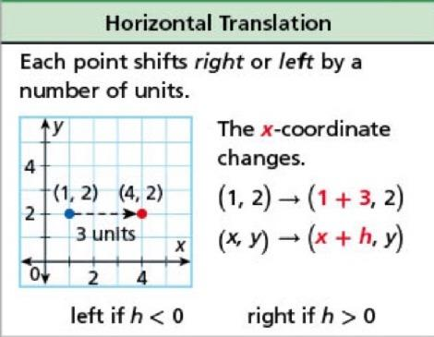
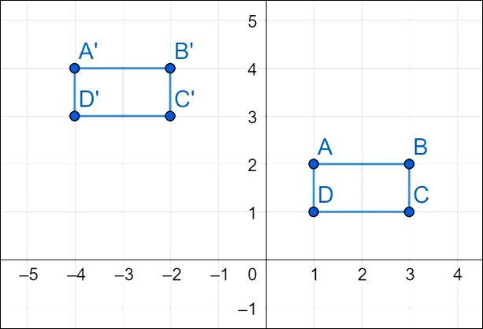
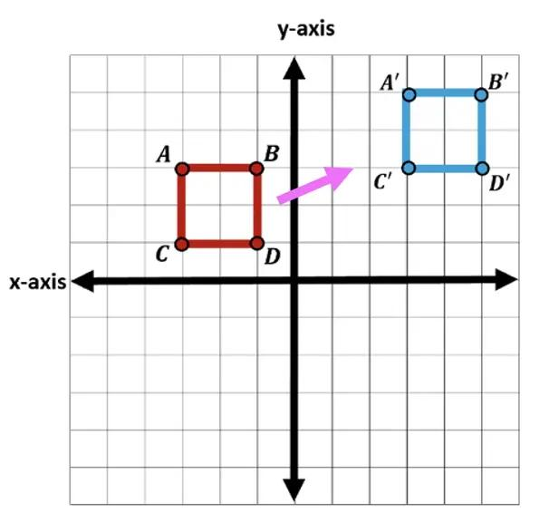

Vertical Translation
# Source: AI Source: Provided by: [Data Path: Persons Table -> ID Column: 1, Name_En Column: Motasem Essam] -> From: [ChatGPT] on [7/25/2026]
If:
$$a=0$$
the figure moves vertically.
Up
$$\boxed{\left(x , y\right)→\left(x , y+b\right)}$$
where:
$$b>0$$
Down
$$\boxed{\left(x , y\right)→\left(x , y-b\right)}$$
where:
$$b>0$$
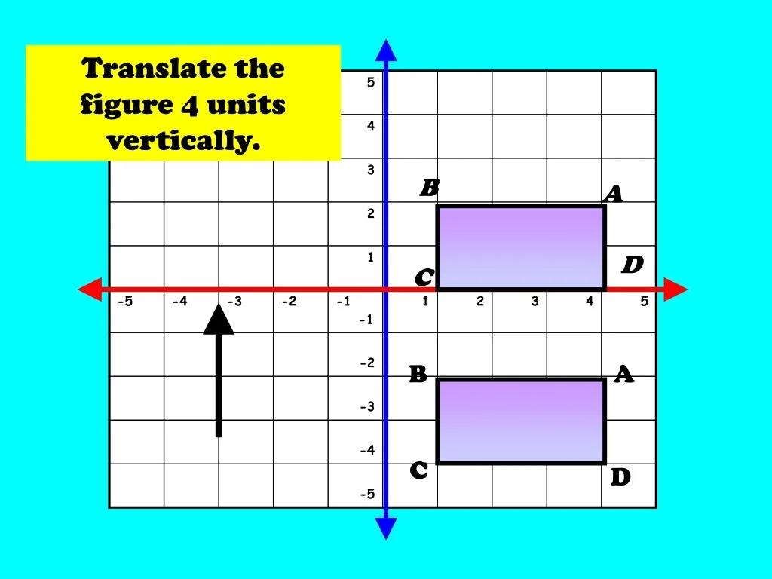
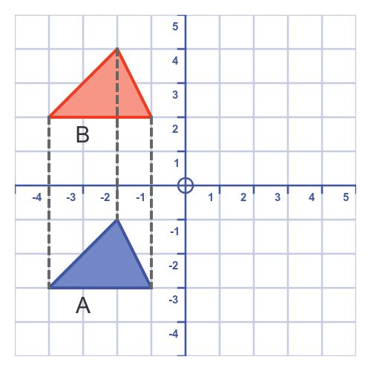
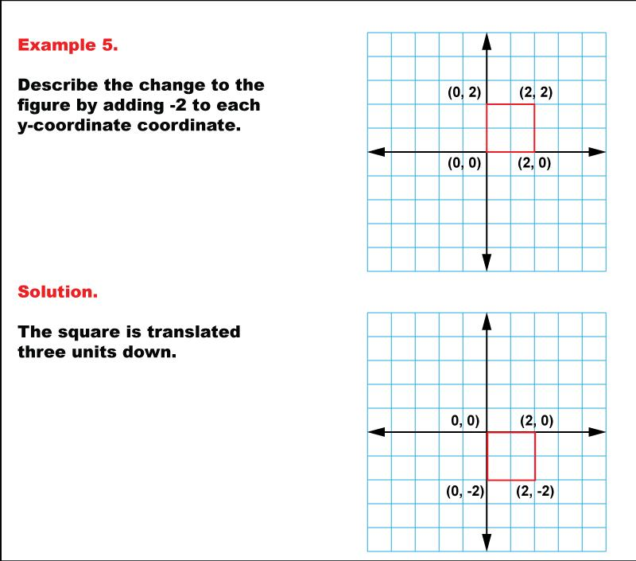
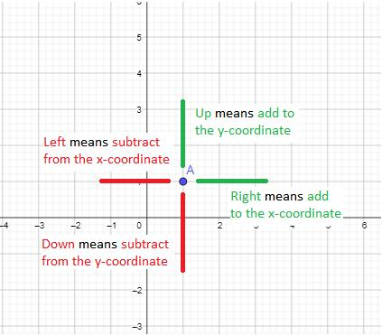
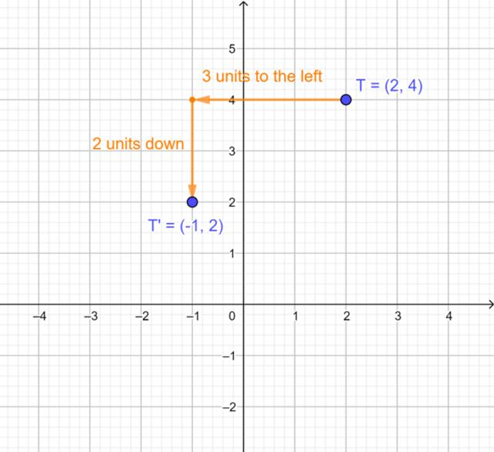

Translation in Both Directions
# Source: AI Source: Provided by: [Data Path: Persons Table -> ID Column: 1, Name_En Column: Motasem Essam] -> From: [ChatGPT] on [7/25/2026]
A figure can move horizontally and vertically at the same time.
For example:
$$\boxed{\left(x , y\right)→\left(x , +3y-5\right)}$$
means:
- $3$ units right
- $5$ units down
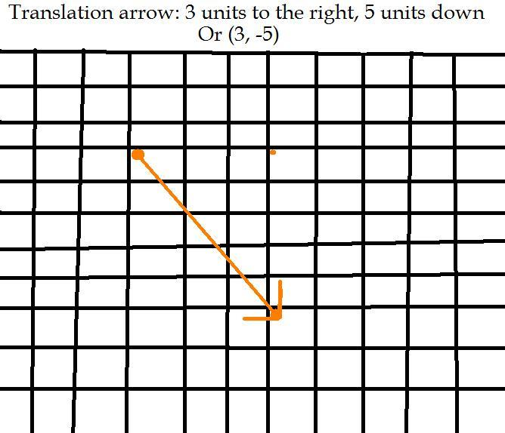
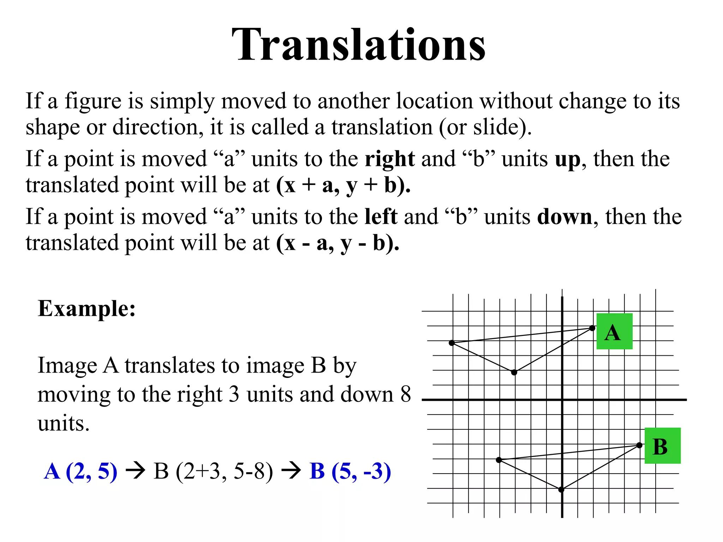
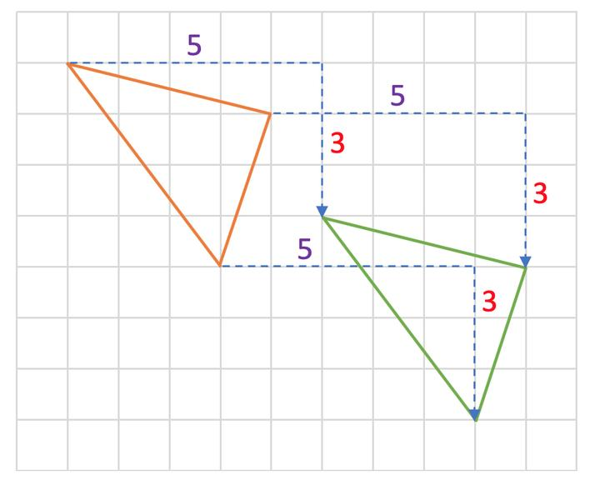

Translation of a Point
# Source: AI Source: Provided by: [Data Path: Persons Table -> ID Column: 1, Name_En Column: Motasem Essam] -> From: [ChatGPT] on [7/25/2026]
Suppose:
$$A=\left(2 , 3\right)$$
and the translation is:
$$\boxed{\left(x , y\right)→\left(x , +4y+2\right)}$$
Then:
$$A^{'}=\left(2 , +43+2\right)$$
Therefore:
$$\boxed{A^{'}=\left(6 , 5\right)}$$
The point moves $4$units right and $2$units up.

Translation of a Figure
# Source: AI Source: Provided by: [Data Path: Persons Table -> ID Column: 1, Name_En Column: Motasem Essam] -> From: [ChatGPT] on [7/25/2026]
Suppose a triangle has vertices:
$$A=\left(1 , 1\right) \\ B=\left(4 , 1\right) \\ C=\left(2 , 3\right)$$
Apply the translation:
$$\boxed{\left(x , y\right)→\left(x , +3y+2\right)}$$
Then:
$$A^{'}=\left(4 , 3\right) \\ B^{'}=\left(7 , 3\right) \\ C^{'}=\left(5 , 5\right)$$
Therefore, the translated triangle has vertices:
$$\boxed{A^{'}\left(4 , 3\right), B^{'}\left(7 , 3\right), C^{'}\left(5 , 5\right)}$$

Translation Notation
# Source: AI Source: Provided by: [Data Path: Persons Table -> ID Column: 1, Name_En Column: Motasem Essam] -> From: [ChatGPT] on [7/25/2026]
A translation can be written as:
$$\boxed{T_{\left(a , b\right)}}$$
where:
$$\left(a , b\right)$$
is the translation vector.
For example:
$$\boxed{T_{\left(5 , -2\right)}}$$
means:
- $5$ units right
- $2$ units down

Translation of Coordinates
# Source: AI Source: Provided by: [Data Path: Persons Table -> ID Column: 1, Name_En Column: Motasem Essam] -> From: [ChatGPT] on [7/25/2026]
The general coordinate rule is:
$$\boxed{\left(x , y\right)→\left(x , +ay+b\right)}$$
Example
For:
$$T_{\left(- , 34\right)}$$
the rule becomes:
$$\boxed{\left(x , y\right)→\left(x , -3y+4\right)}$$
Therefore:
- $3$ units left
- $4$ units up

Translation Preserves Distance
# Source: AI Source: Provided by: [Data Path: Persons Table -> ID Column: 1, Name_En Column: Motasem Essam] -> From: [ChatGPT] on [7/25/2026]
Translation does not change distances between corresponding points.
If:
$$AB=5$$
then after translation:
$$A^{'}B^{'}=5$$
Therefore:
$$\boxed{AB=A^{'}B^{'}}$$
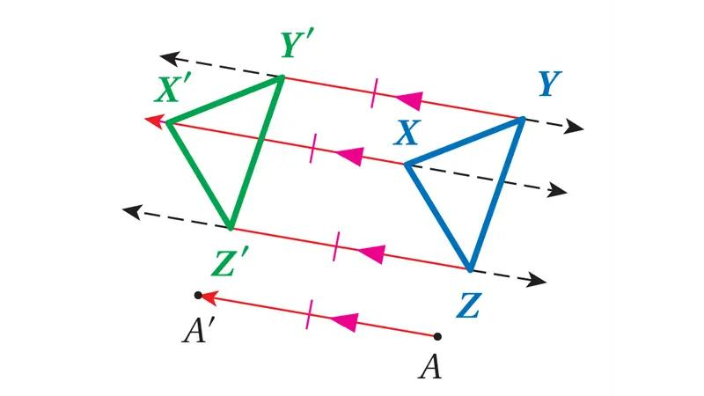
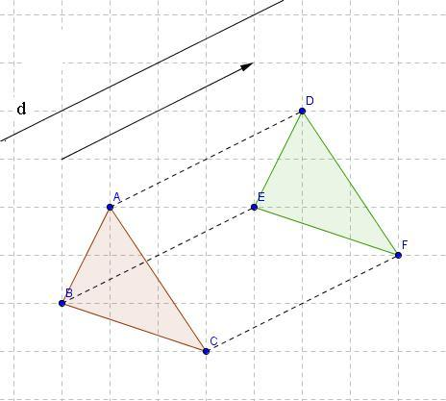
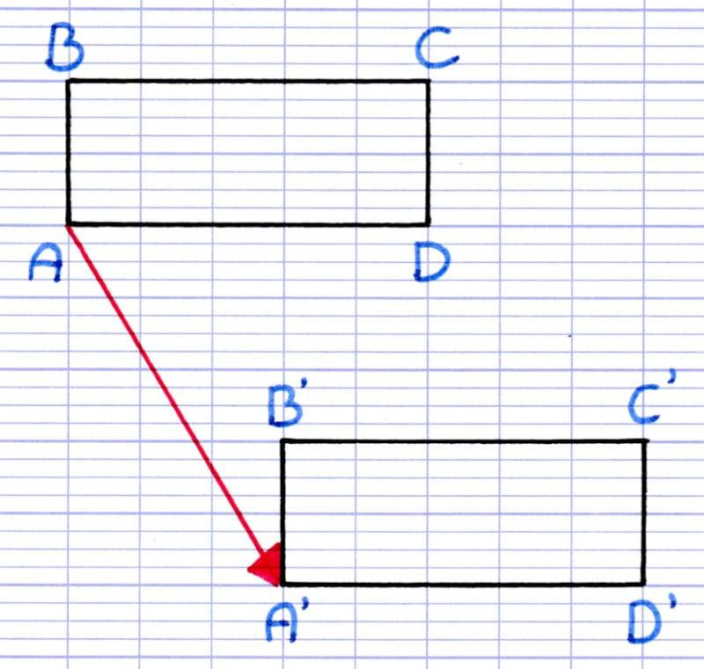
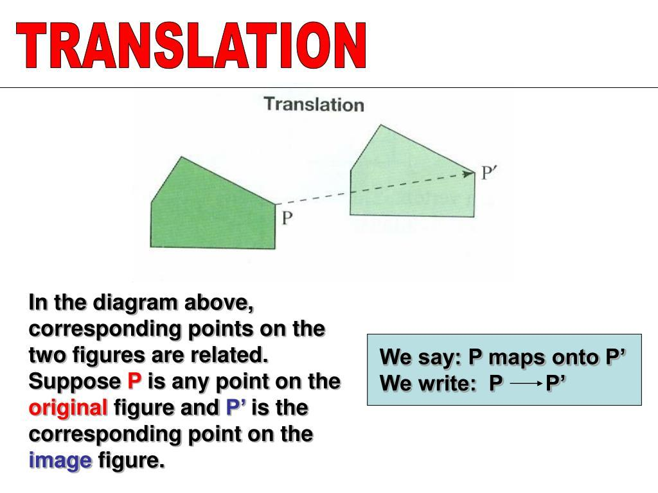
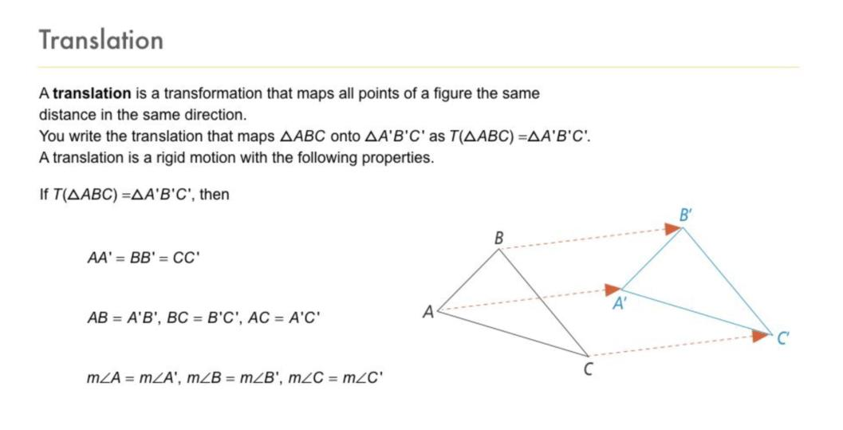
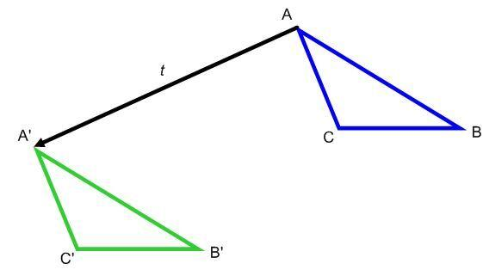

Translation Preserves Angles
# Source: AI Source: Provided by: [Data Path: Persons Table -> ID Column: 1, Name_En Column: Motasem Essam] -> From: [ChatGPT] on [7/25/2026]
A translation preserves all angle measures.
If:
$$∠A={60}^{∘}$$
then:
$$∠A^{'}={60}^{∘}$$
Therefore:
$$\boxed{∠A=∠A^{'}}$$

Translation Preserves Shape
# Source: AI Source: Provided by: [Data Path: Persons Table -> ID Column: 1, Name_En Column: Motasem Essam] -> From: [ChatGPT] on [7/25/2026]
The translated figure has exactly the same shape as the original figure.
$$\boxed{{\text{Shape}}_{original}={\text{Shape}}_{translated}}$$
There is no stretching, shrinking, or distortion.

Translation Preserves Size
# Source: AI Source: Provided by: [Data Path: Persons Table -> ID Column: 1, Name_En Column: Motasem Essam] -> From: [ChatGPT] on [7/25/2026]
All corresponding lengths remain unchanged.
If:
$$AB=7$$
then:
$$A^{'}B^{'}=7$$
Therefore:
$$\boxed{\text{Size is preserved}}$$

Translation Preserves Orientation
# Source: AI Source: Provided by: [Data Path: Persons Table -> ID Column: 1, Name_En Column: Motasem Essam] -> From: [ChatGPT] on [7/25/2026]
A translation does not rotate or reflect a figure.
The figure maintains the same orientation.
For example, if a triangle points upward before translation, it still points upward afterward.
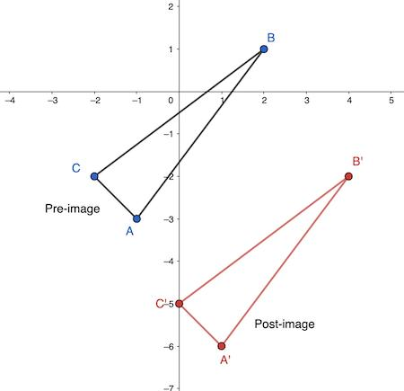
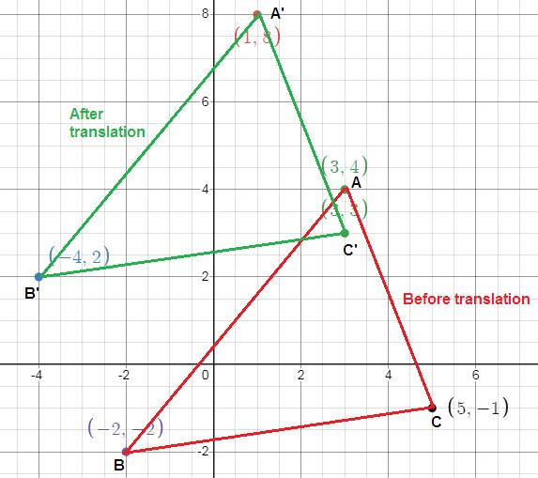
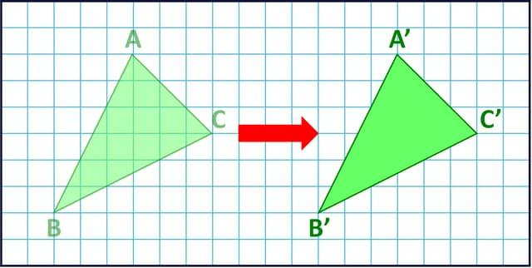

Translation and Congruence
# Source: AI Source: Provided by: [Data Path: Persons Table -> ID Column: 1, Name_En Column: Motasem Essam] -> From: [ChatGPT] on [7/25/2026]
Because translation preserves:
- Side lengths
- Angles
- Shape
- Size
the original and translated figures are congruent.
$$\boxed{F≅F^{'}}$$

Translation and Area
# Source: AI Source: Provided by: [Data Path: Persons Table -> ID Column: 1, Name_En Column: Motasem Essam] -> From: [ChatGPT] on [7/25/2026]
Translation does not change the area of a figure.
If:
$$A=20$$
then after translation:
$$\boxed{A^{'}=20}$$
Therefore:
$$\boxed{A^{'}=A}$$

Translation and Perimeter
# Source: AI Source: Provided by: [Data Path: Persons Table -> ID Column: 1, Name_En Column: Motasem Essam] -> From: [ChatGPT] on [7/25/2026]
Translation does not change the perimeter.
If:
$$P=30$$
then:
$$\boxed{P^{'}=30}$$
Therefore:
$$\boxed{P^{'}=P}$$

Translation and Distance from the Origin
# Source: AI Source: Provided by: [Data Path: Persons Table -> ID Column: 1, Name_En Column: Motasem Essam] -> From: [ChatGPT] on [7/25/2026]
Although the distances within the figure remain unchanged, the distance of the figure from the coordinate origin may change.
For example:
$$A=\left(1 , 1\right)$$
translated by:
$$\left(5 , 2\right)$$
gives:
$$A^{'}=\left(6 , 3\right)$$
The point has moved farther from the origin, but its geometric relationships with the other points remain unchanged.

Translation as a Vector Movement
# Source: AI Source: Provided by: [Data Path: Persons Table -> ID Column: 1, Name_En Column: Motasem Essam] -> From: [ChatGPT] on [7/25/2026]
Suppose:
$$\vec{v}=\left(\begin{matrix}4 \\ 3\end{matrix}\right)$$
Then every point is moved by this same vector.
$$\boxed{\left(\begin{matrix}x^{'} \\ y^{'}\end{matrix}\right)=\left(\begin{matrix}x \\ y\end{matrix}\right)+\left(\begin{matrix}4 \\ 3\end{matrix}\right)}$$
Therefore:
$$\boxed{x^{'}=x+4} \\ \boxed{y^{'}=y+3}$$

Translation in a Coordinate Plane
# Source: AI Source: Provided by: [Data Path: Persons Table -> ID Column: 1, Name_En Column: Motasem Essam] -> From: [ChatGPT] on [7/25/2026]
Translation is especially easy to visualize on a Cartesian coordinate plane.
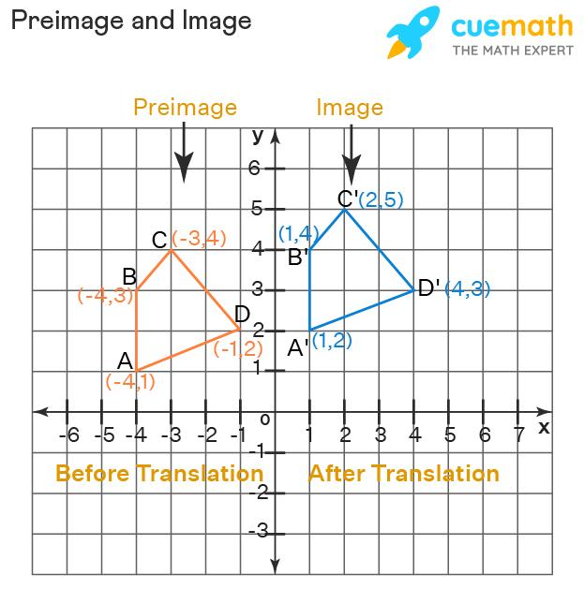
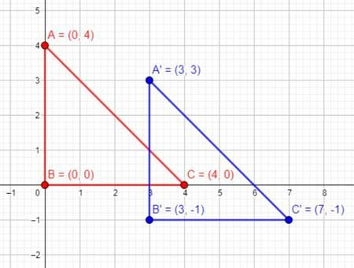
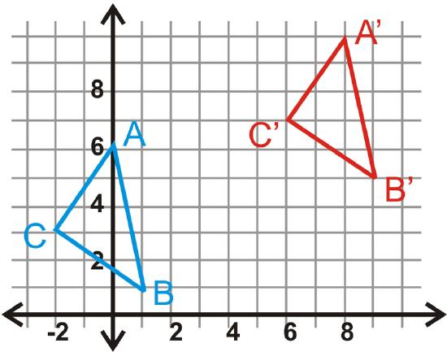
For example:
$$T_{\left(6 , -4\right)}$$
means every point moves:
$$6\text{ units right}$$
and:
$$4\text{ units down}$$

Composition of Translations
# Source: AI Source: Provided by: [Data Path: Persons Table -> ID Column: 1, Name_En Column: Motasem Essam] -> From: [ChatGPT] on [7/25/2026]
Two or more translations can be performed one after another.
Suppose the first translation is:
$$T_{\left(3 , 2\right)}$$
and the second is:
$$T_{\left(4 , -1\right)}$$
The combined translation is:
$$\left(3 , 2\right)+\left(4 , -1\right) \\ =\left(7 , 1\right)$$
Therefore:
$$\boxed{T_{\left(7 , 1\right)}}$$
The two translations are equivalent to one translation of $7$units right and $1$unit up.

Translation in One Dimension
# Source: AI Source: Provided by: [Data Path: Persons Table -> ID Column: 1, Name_En Column: Motasem Essam] -> From: [ChatGPT] on [7/25/2026]
Translation can also occur along a single axis.
For example:
$$x→x+5$$
means every point moves $5$units to the right.
Similarly:
$$x→x-5$$
means every point moves $5$units to the left.

Translation of a Line Segment
# Source: AI Source: Provided by: [Data Path: Persons Table -> ID Column: 1, Name_En Column: Motasem Essam] -> From: [ChatGPT] on [7/25/2026]
Suppose:
$$A=\left(1 , 2\right)$$
and:
$$B=\left(5 , 2\right)$$
Apply:
$$T_{\left(3 , 4\right)}$$
Then:
$$A^{'}=\left(4 , 6\right)$$
and:
$$B^{'}=\left(8 , 6\right)$$
The original length is:
$$AB=4$$
and the translated length is:
$$A^{'}B^{'}=4$$
Therefore:
$$\boxed{AB=A^{'}B^{'}}$$

Translation of a Circle
# Source: AI Source: Provided by: [Data Path: Persons Table -> ID Column: 1, Name_En Column: Motasem Essam] -> From: [ChatGPT] on [7/25/2026]
A circle can also be translated.
Suppose the circle has center:
$$O=\left(2 , 3\right)$$
and radius:
$$r=5$$
Apply:
$$T_{\left(4 , -2\right)}$$
The new center is:
$$O^{'}=\left(6 , 1\right)$$
The radius remains:
$$\boxed{r^{'}=5}$$
Therefore, the circle moves without changing its size.
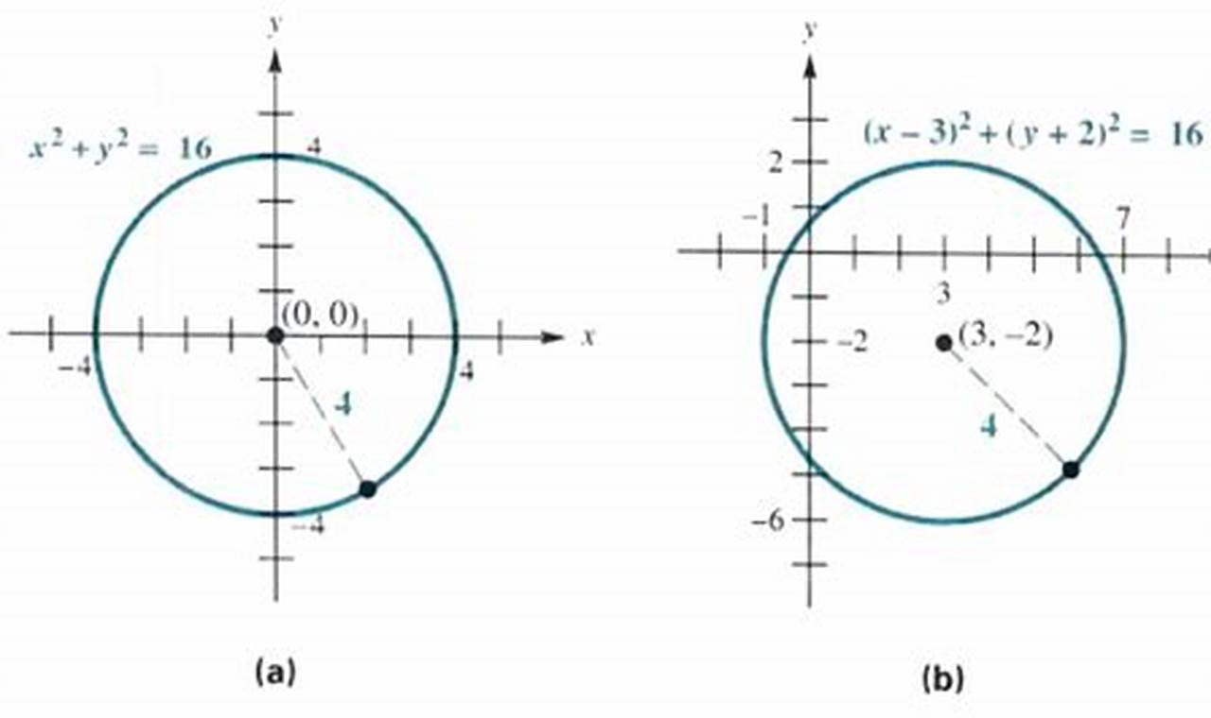
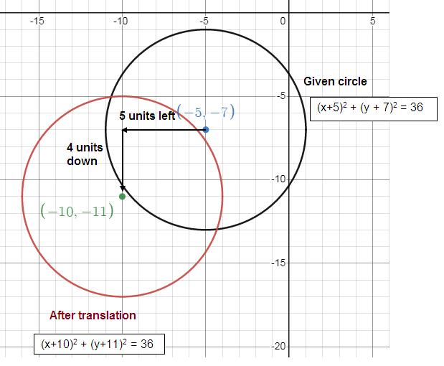
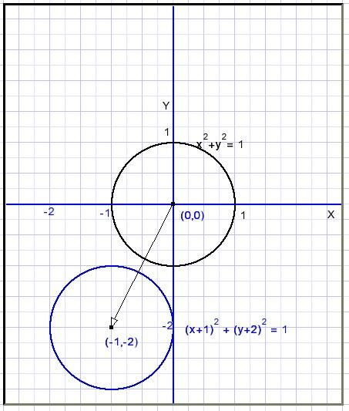
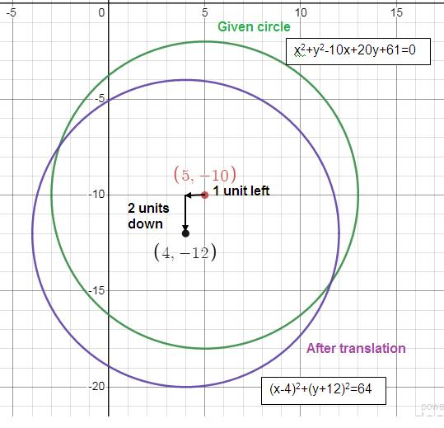
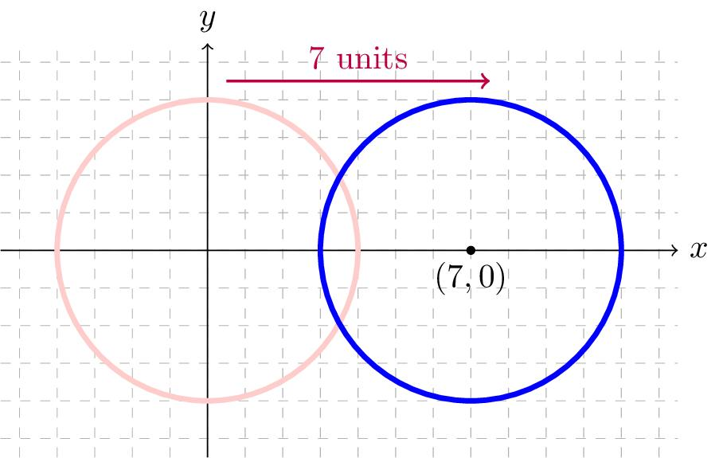

Translation of a Polygon
# Source: AI Source: Provided by: [Data Path: Persons Table -> ID Column: 1, Name_En Column: Motasem Essam] -> From: [ChatGPT] on [7/25/2026]
Every vertex of a polygon is translated by the same vector.
If:
$$P_{i}=\left(x_{i} , y_{i}\right)$$
then:
$$\boxed{P_{i}^{'}=\left(x_{i} , +ay_{i}+b\right)}$$
for every vertex.
Thus, a polygon maintains its:
- Number of vertices
- Side lengths
- Interior angles
- Area
- Perimeter
- Shape

Real-World Examples
# Source: AI Source: Provided by: [Data Path: Persons Table -> ID Column: 1, Name_En Column: Motasem Essam] -> From: [ChatGPT] on [7/25/2026]
Translation can model:
- Moving a car along a straight path.
- Moving a box across a floor.
- Moving objects in computer graphics.
- Repeating patterns.
- Moving objects in CAD.
- Sliding doors.
- Conveyor-belt movement.
- Moving game characters.
- Shifting architectural components.
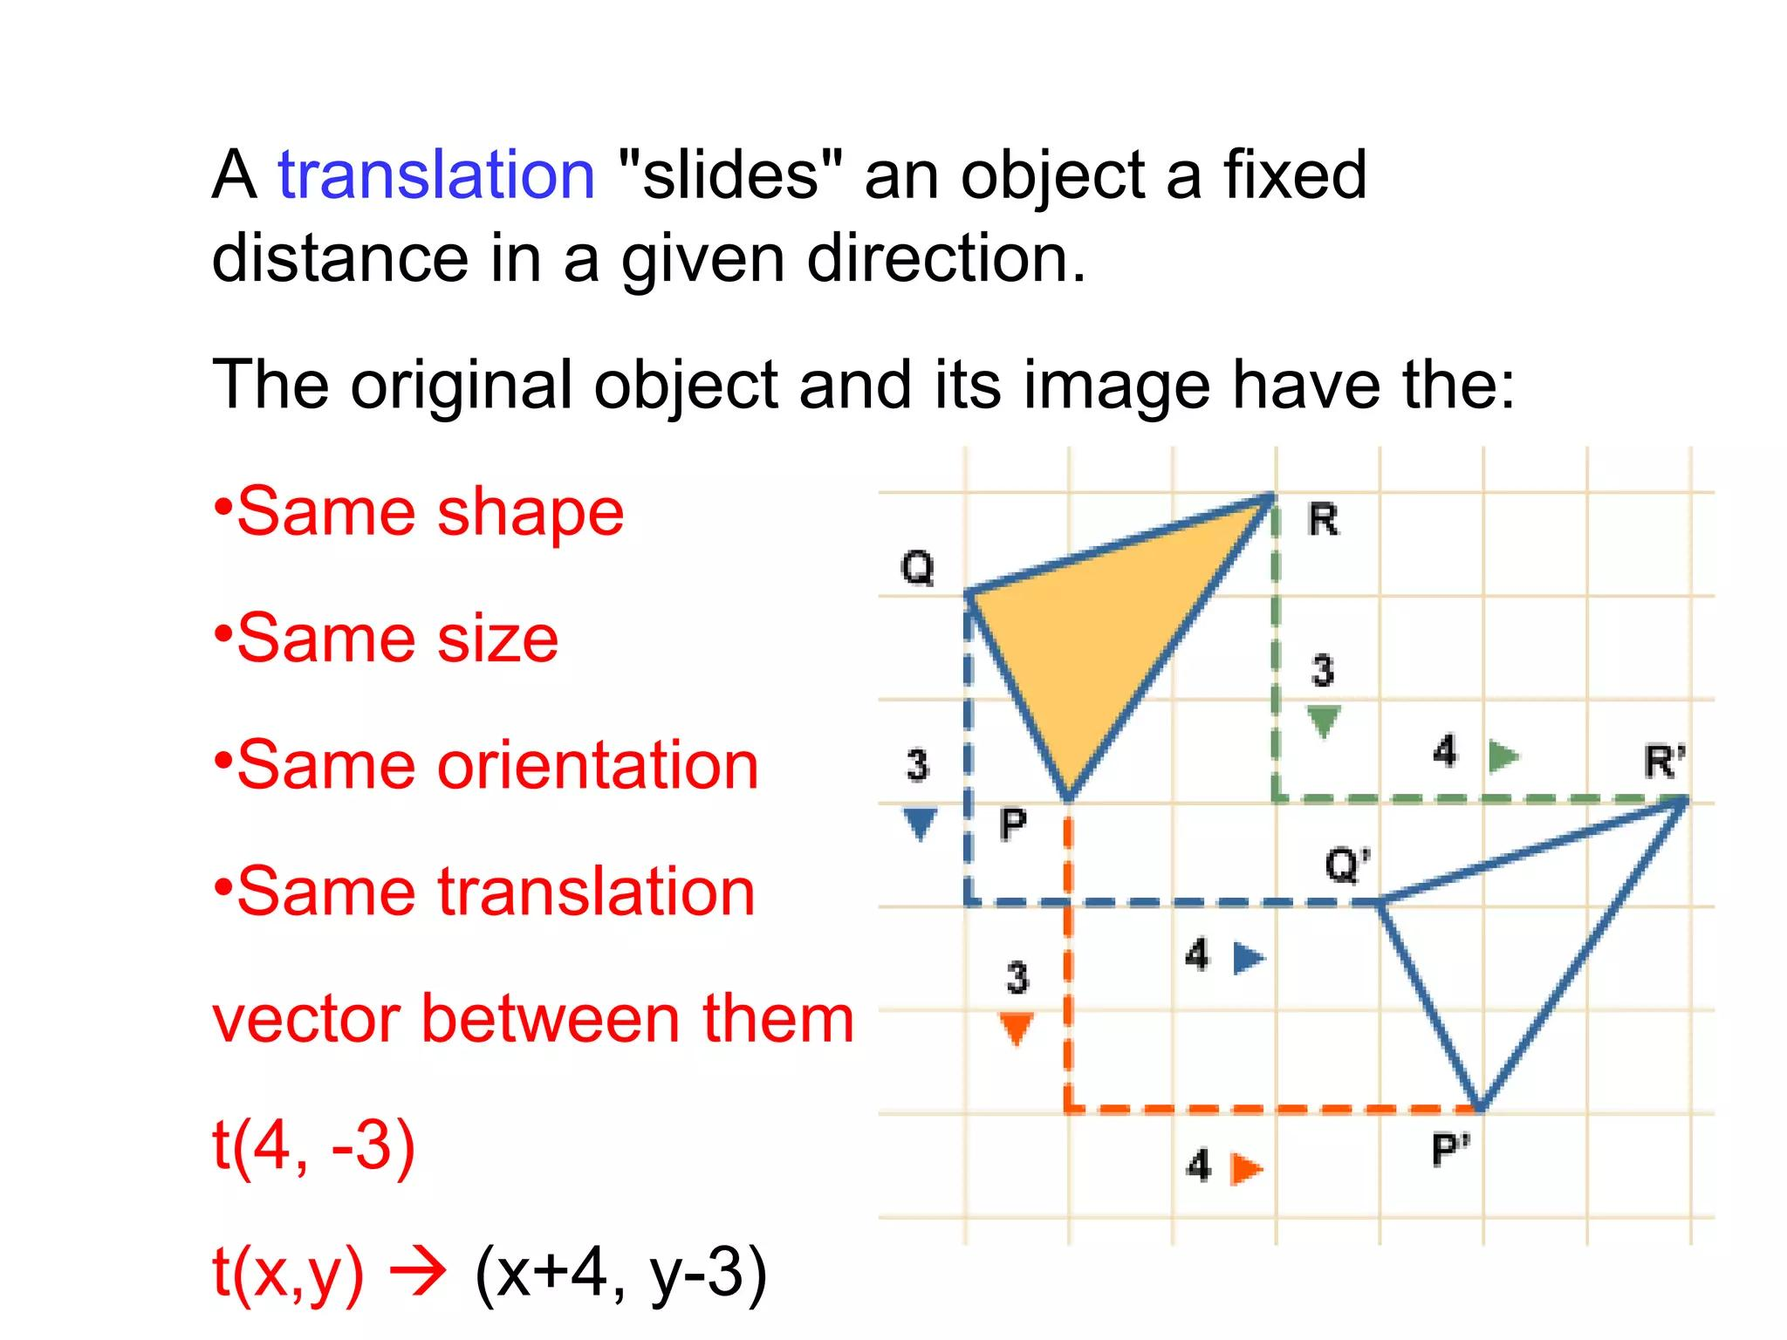
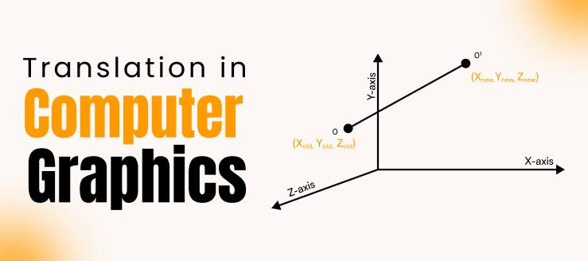
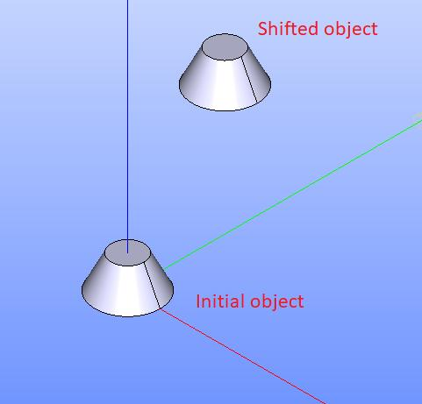
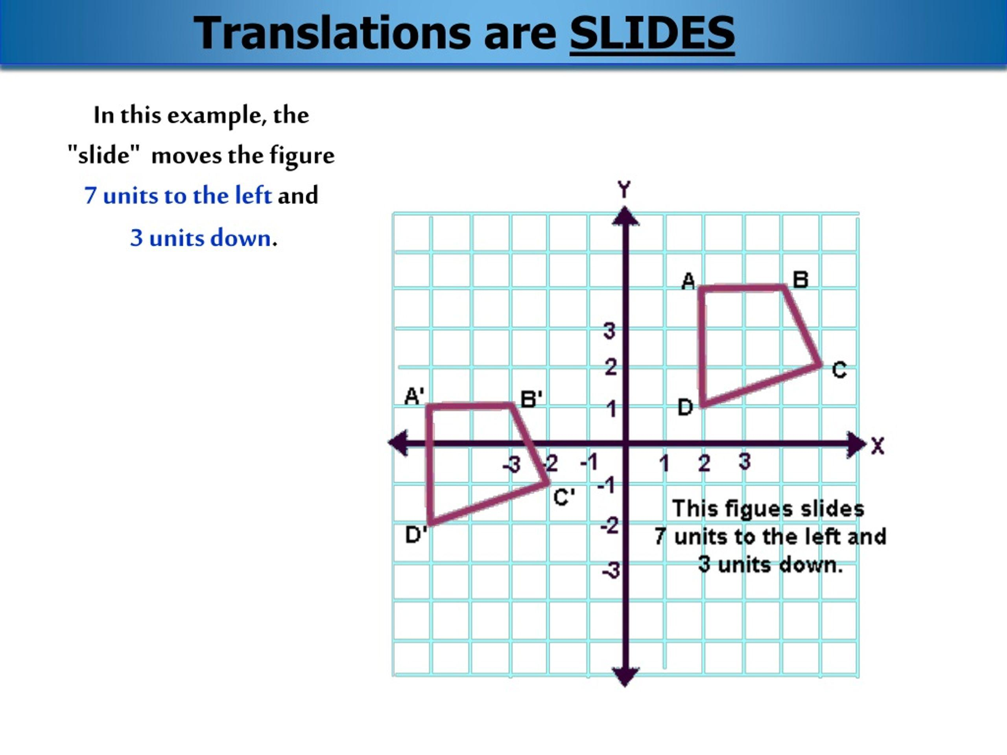
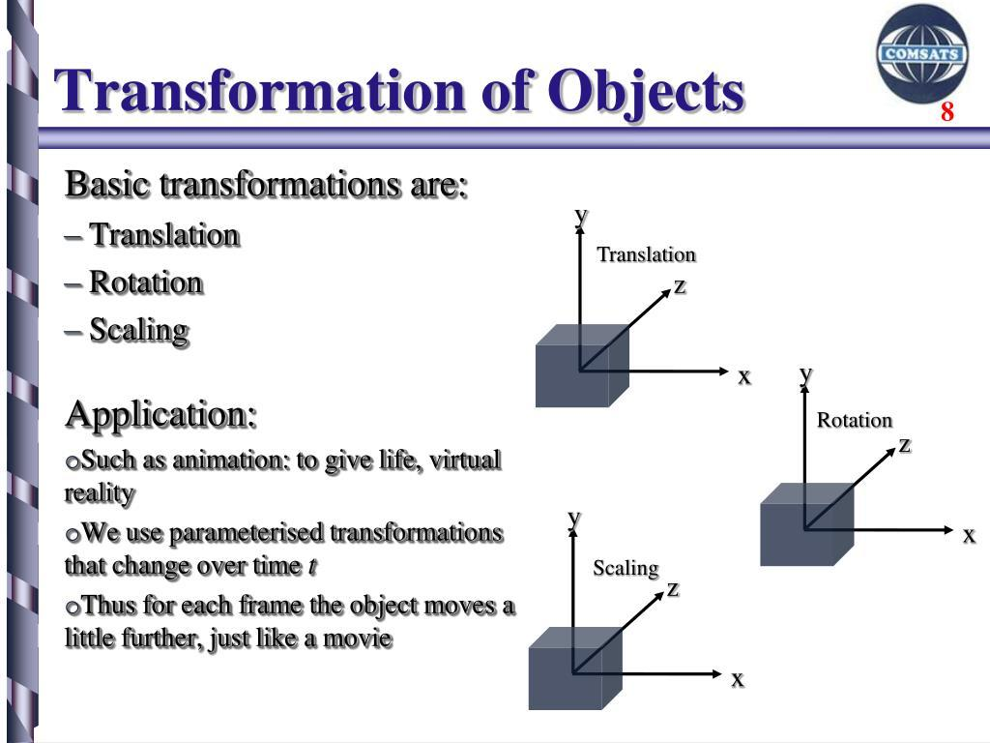
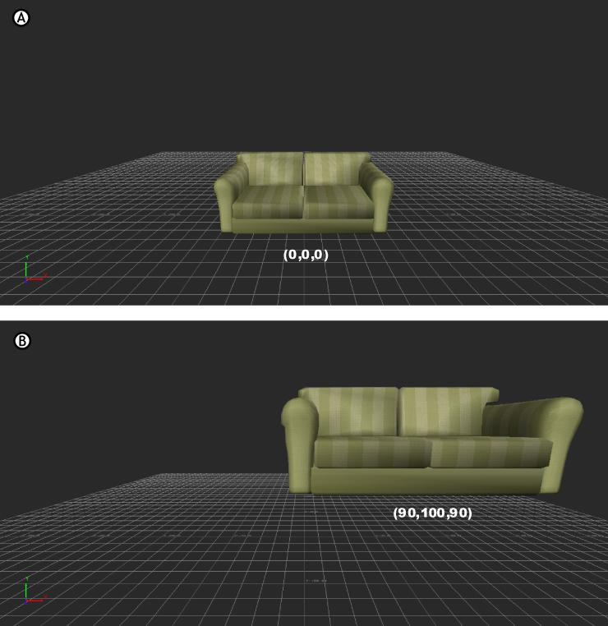
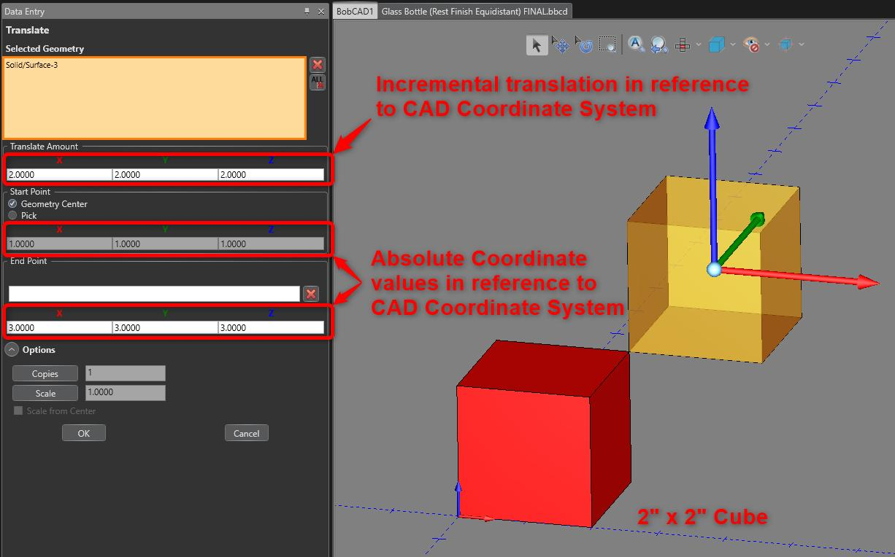

Translation in Computer Graphics
# Source: AI Source: Provided by: [Data Path: Persons Table -> ID Column: 1, Name_En Column: Motasem Essam] -> From: [ChatGPT] on [7/25/2026]
Computer graphics use translation to change the position of objects.
If an object's coordinates are:
$$\left(x , y\right)$$
and the translation vector is:
$$\left(a , b\right)$$
then:
$$\boxed{\left(x^{'} , y^{'}\right)=\left(x , +ay+b\right)}$$
This is used to move:
- Characters
- Images
- Shapes
- Game objects
- 2D models
- UI elements

Translation in CAD
# Source: AI Source: Provided by: [Data Path: Persons Table -> ID Column: 1, Name_En Column: Motasem Essam] -> From: [ChatGPT] on [7/25/2026]
In CAD systems, translation is used to move geometric objects while preserving their dimensions.
A translated object maintains:
$$\boxed{\text{Shape}} \\ \boxed{\text{Size}} \\ \boxed{\text{Orientation}}$$
Only its position changes.

Translation in Pattern Design
# Source: AI Source: Provided by: [Data Path: Persons Table -> ID Column: 1, Name_En Column: Motasem Essam] -> From: [ChatGPT] on [7/25/2026]
Repeated translations can create patterns.
For example, translating the same shape repeatedly by a fixed vector:
$$T_{\left(a , b\right)}$$
creates a repeating geometric pattern.
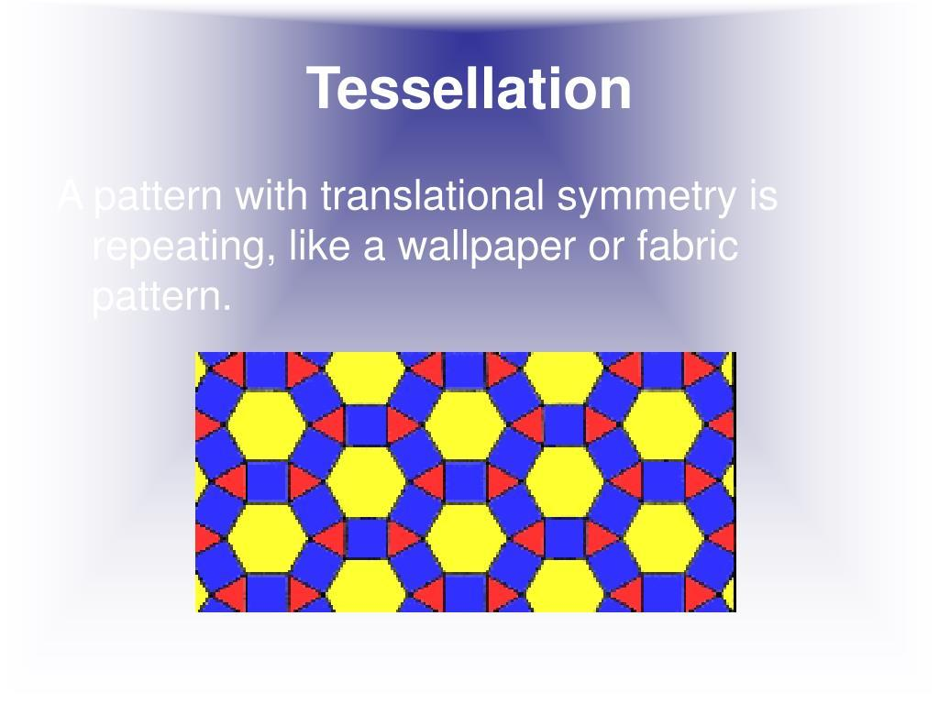
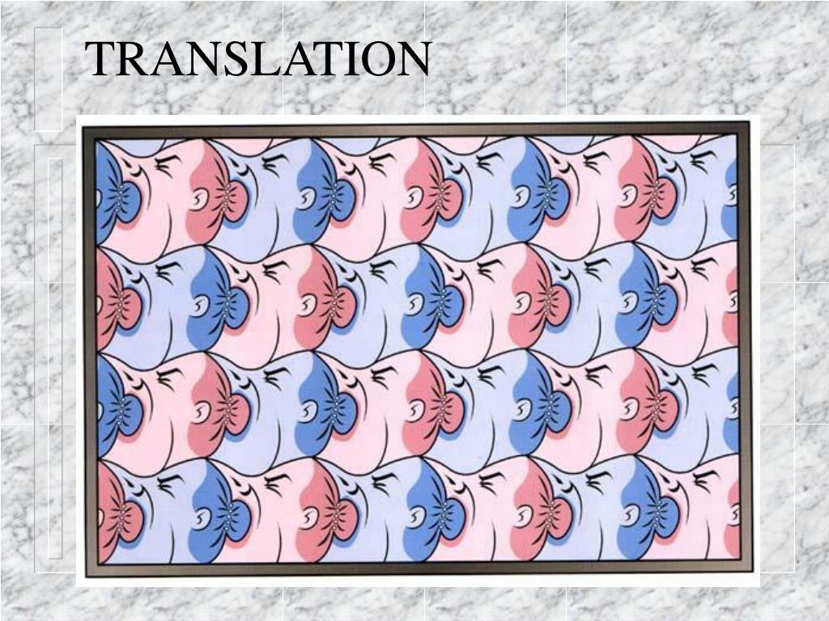
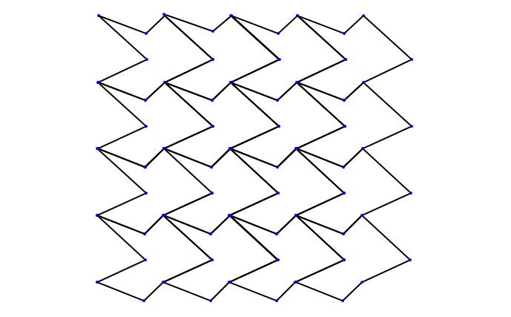
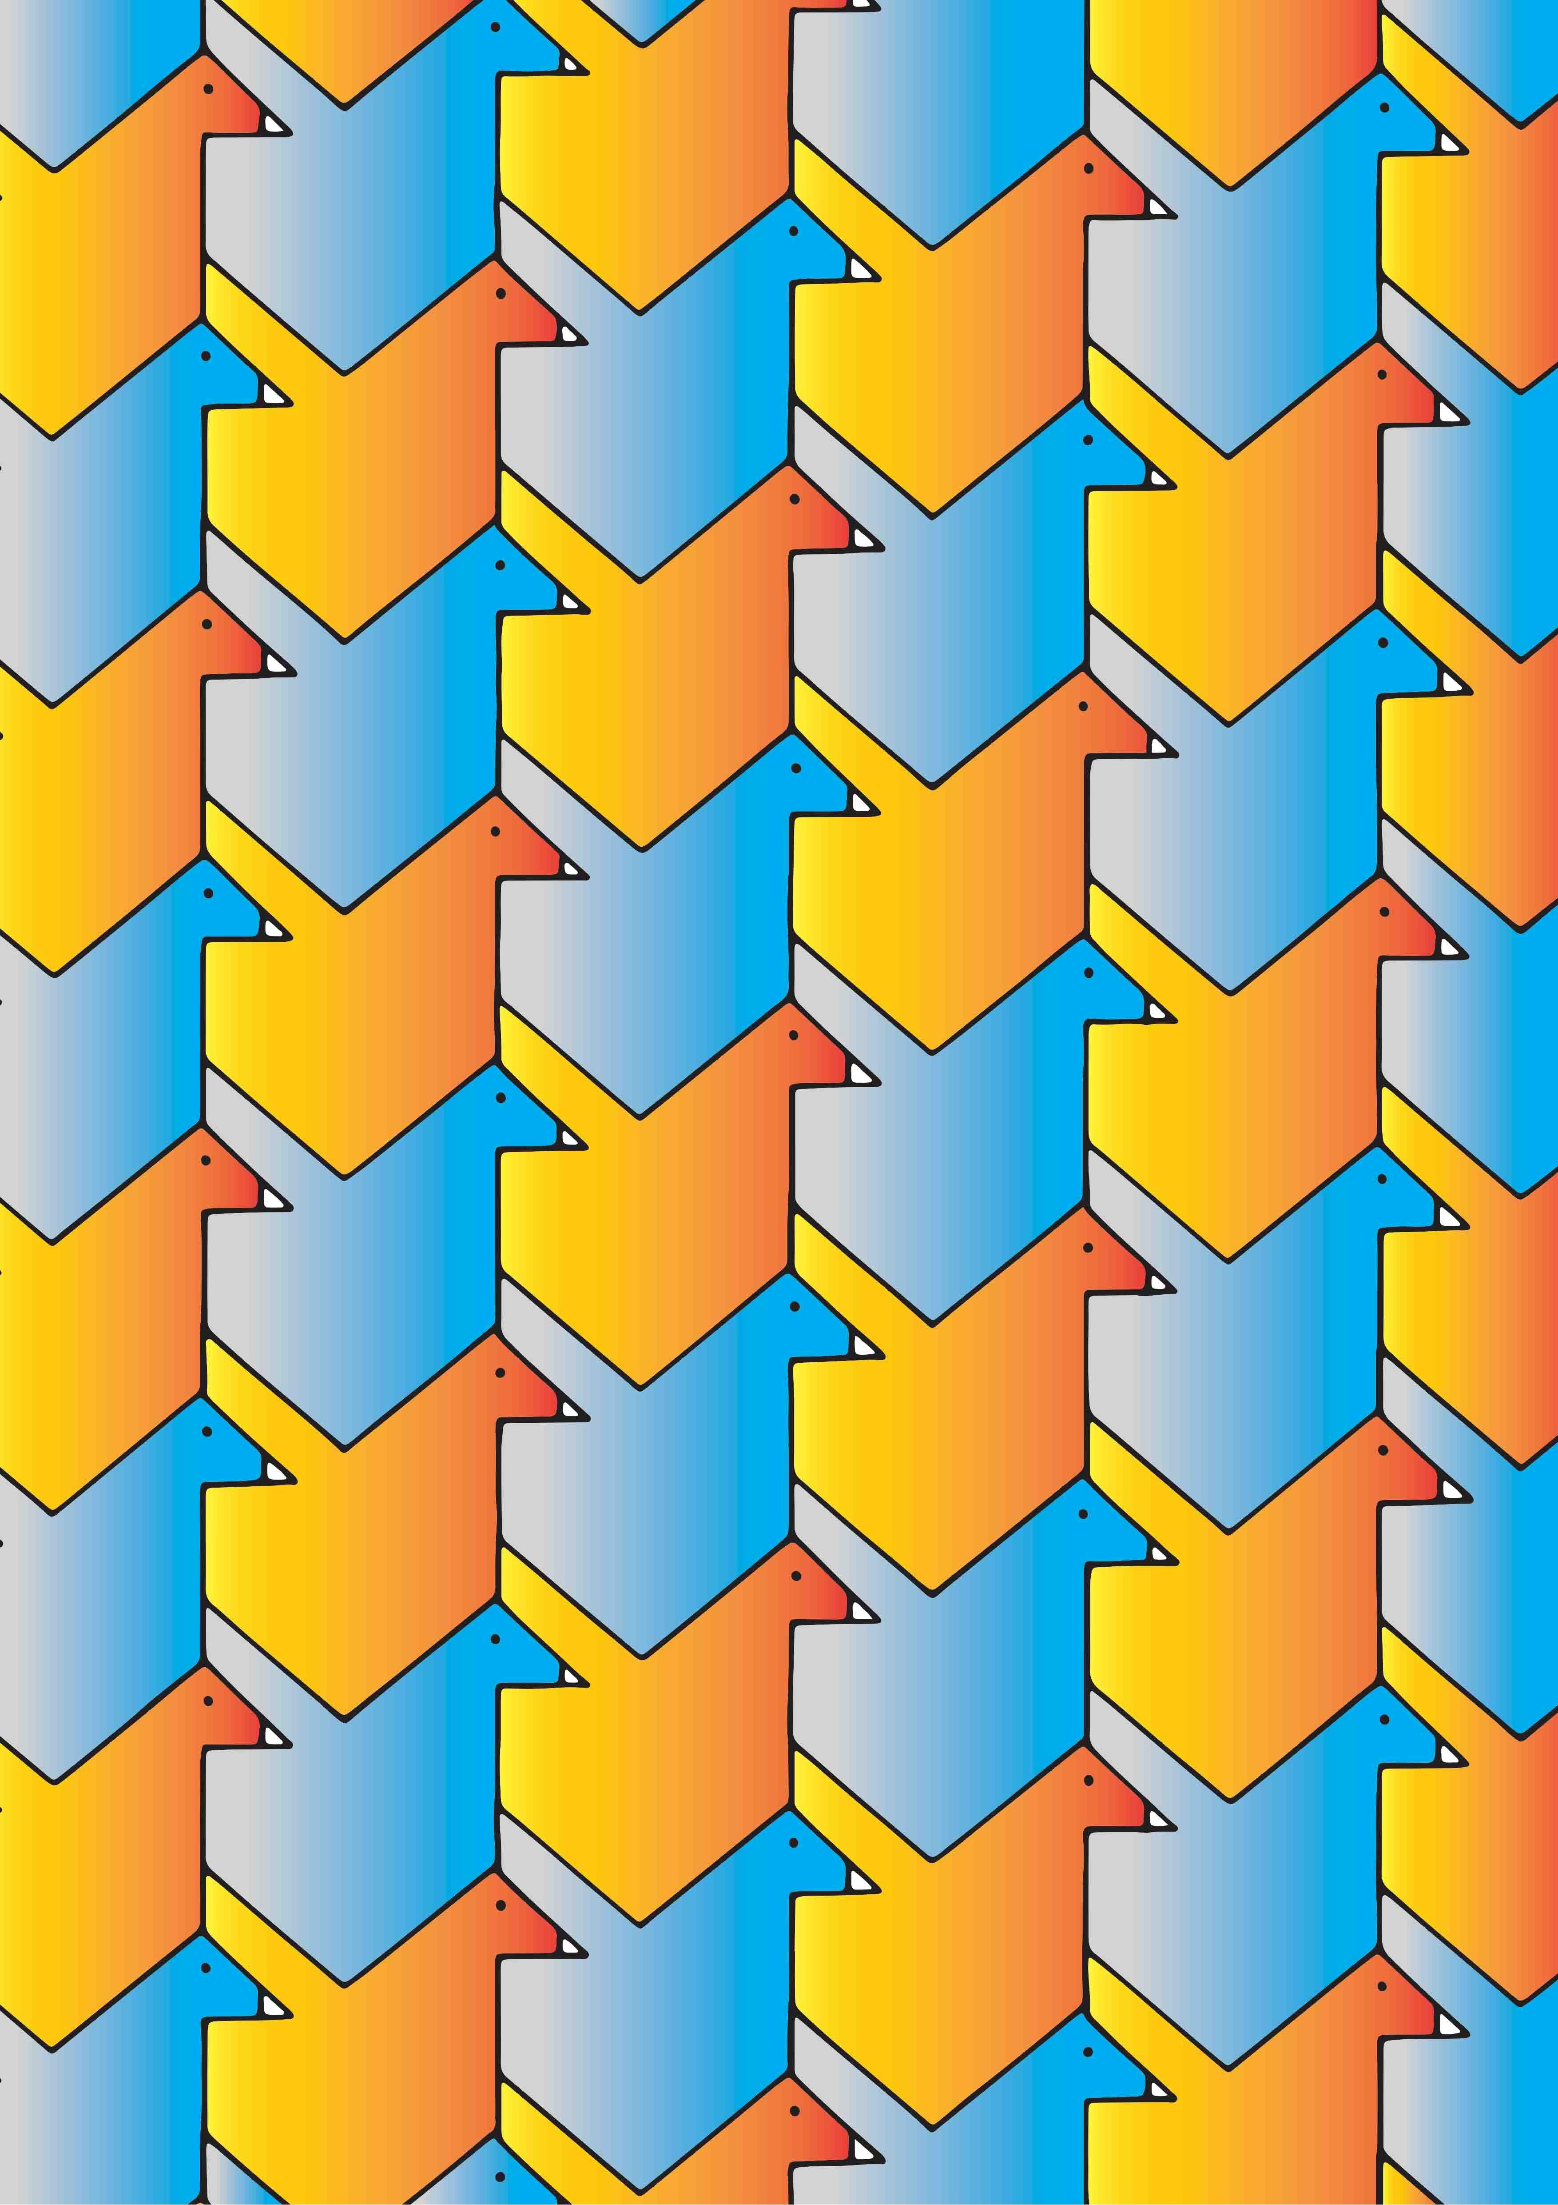

Advantages
# Source: AI Source: Provided by: [Data Path: Persons Table -> ID Column: 1, Name_En Column: Motasem Essam] -> From: [ChatGPT] on [7/25/2026]
Studying translation helps to:
- Understand geometric transformations.
- Move figures accurately.
- Work with coordinate geometry.
- Understand vectors.
- Create geometric patterns.
- Model movement.
- Develop computer graphics.
- Perform CAD transformations.
- Solve transformation problems.

Limitations
# Source: AI Source: Provided by: [Data Path: Persons Table -> ID Column: 1, Name_En Column: Motasem Essam] -> From: [ChatGPT] on [7/25/2026]
Translation:
- Changes only position.
- Cannot change the size of a figure.
- Cannot rotate a figure.
- Cannot reflect a figure.
- Cannot distort the shape.
- Cannot independently move different points of a rigid figure.

Comparison with Other Transformations
# Source: AI Source: Provided by: [Data Path: Persons Table -> ID Column: 1, Name_En Column: Motasem Essam] -> From: [ChatGPT] on [7/25/2026]
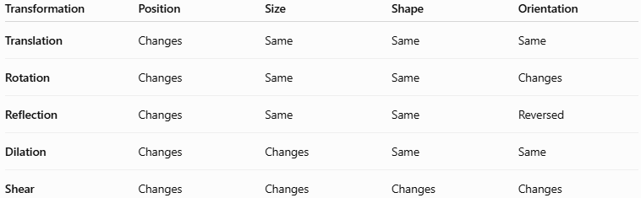
Transformation | Position | Size | Shape | Orientation
Translation | Changes | Same | Same | Same
Rotation | Changes | Same | Same | Changes
Reflection | Changes | Same | Same | Reversed
Dilation | Changes | Changes | Same | Same
Shear | Changes | Changes | Changes | Changes
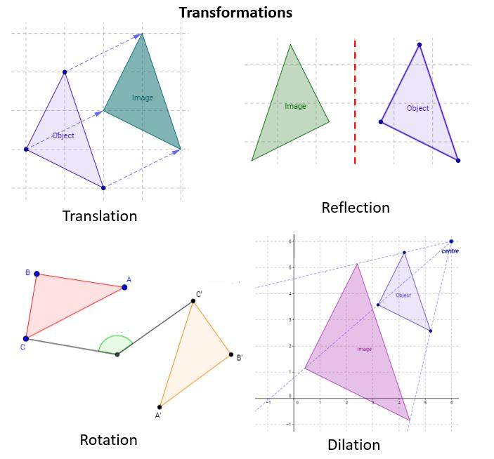
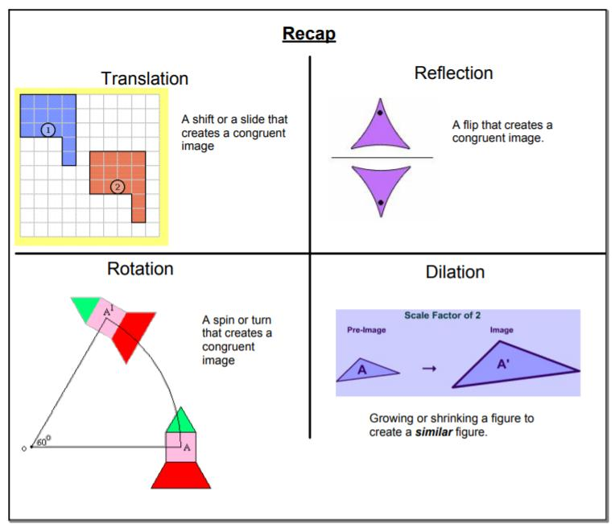
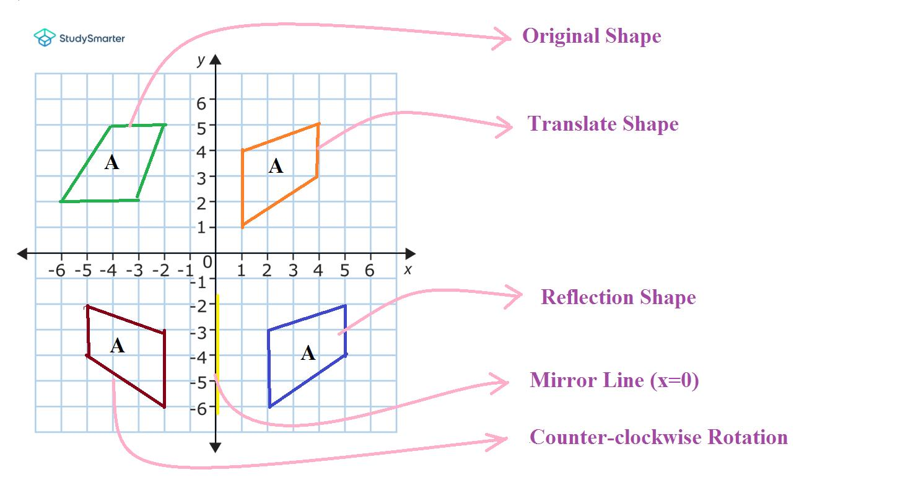
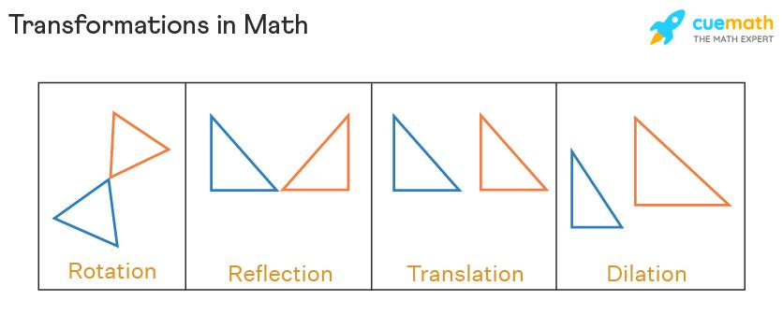

Key Points
# Source: AI Source: Provided by: [Data Path: Persons Table -> ID Column: 1, Name_En Column: Motasem Essam] -> From: [ChatGPT] on [7/25/2026]
- Translation moves every point of a figure the same distance in the same direction.
- A translation is represented by a vector.
- The general coordinate rule is:
$$\boxed{\left(x , y\right)→\left(x , +ay+b\right)}$$
- $a$represents horizontal movement.
- $b$represents vertical movement.
- Translation preserves:
  - Shape
  - Size
  - Side lengths
  - Angles
  - Area
  - Perimeter
  - Orientation
- The original and translated figures are congruent.
- Multiple translations can be combined into one translation.

Conclusion
# Source: AI Source: Provided by: [Data Path: Persons Table -> ID Column: 1, Name_En Column: Motasem Essam] -> From: [ChatGPT] on [7/25/2026]
Translation is a fundamental type of geometric transformation in which every point of a figure moves by the same distance and in the same direction. It changes only the position of the figure while preserving its shape, size, orientation, angles, side lengths, area, and perimeter. In coordinate geometry, translation is represented by:
$$\boxed{\left(x , y\right)→\left(x , +ay+b\right)}$$
Translation is widely used in plane geometry, coordinate geometry, vectors, computer graphics, CAD, engineering, animation, robotics, and pattern design.

